

**DEPARTMENT OF PHYSICS**

**SESSION 2023-24**

**TERM PAPER ASSIGNMENT**

**ON**

**"CHARACTERIZATION OF LIQUID CRYSTALS"**

**BY**

**ANURAG SEMWAL**

ROLL NO: 2110011016829

CLASS: BSc. Semester 5

**Acknowledgment**

First and foremost, I express special and heartfelt thanks to ***Dr. RB Singh***, Professor of the University of Lucknow, for his guidance, support, and kind help throughout my project. I express my deep gratitude and sincere thanks to him, throughout this thesis work he provided me with continuous scientific help which provided me with the determination that is always indispensable.

I would like to thank ***Dr. NK Pandey*** (Head of the Department) for providing such a scientific atmosphere and making available the necessary facilities for this thesis work.

Finally, I would like to thank my friends and my parents for their support, who were the fountainhead of my moral strength.

**Anurag Semwal**

Introduction

The forms of matter that we are most aware of are solid, liquid, and gas. The difference between solids and liquids is that in solids the molecules are arranged in a definite order while in liquids they are diffused randomly. The **Liquid Crystal State is an** **intermediate state between solids and liquids**. The molecules in all liquid crystal phases diffuse about much like molecules of liquid, but they do so maintain some degree of order (orientational and positional) like solids.

Crystalline solids have both positional and orientational order over a long range while **liquid crystals possess 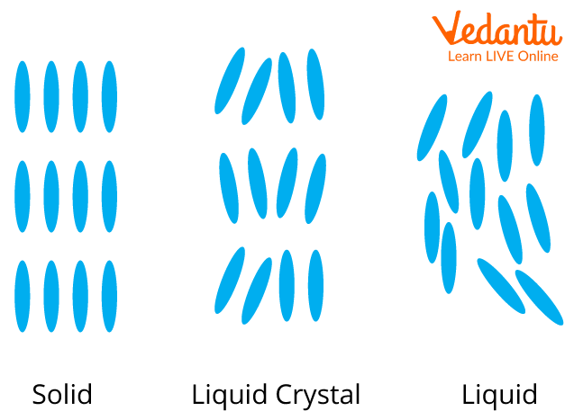long-range orientational order and weak positional order**.

Given aside is a diagrammatic representation of what the phases look like. These phase changes occur on increasing the temperature from solid to intermediate liquid crystal state to liquid state.

History of Discovery of Liquid Crystals

The story begins with **Austrian botanist Friedrich Reinitzer** in 1888. While studying **cholesteryl benzoate** extracted from carrots, he observed something peculiar – **the substance exhibited two melting points!** This defied the known behavior of solids and liquids. Reinitzer meticulously documented his findings, laying the groundwork for future research.

**Otto Lehmann**, a German physicist, picked up the trail in 1889. He **coined the term "flowing crystal"** for this strange state of matter, recognizing its properties resembling both liquids and solids. Lehmann dedicated years to studying and classifying different types of liquid crystals, laying the foundation for the field.

The 1960s witnessed a pivotal breakthrough. **James Fergason** and his colleagues at Westinghouse Electric Corporation **developed the first practical liquid crystal display (LCD)**. This revolutionized display technology, paving the way for everything from calculators and watches to TVs and smartphones.

Liquid crystals haven't stopped there. Their unique properties have found **applications in diverse fields like sensors, lasers, and medical imaging**. Research continues, pushing the boundaries of what these versatile materials can achieve.

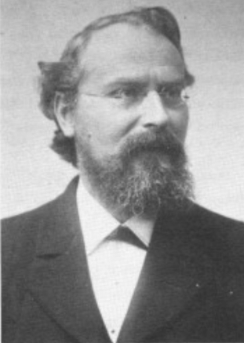 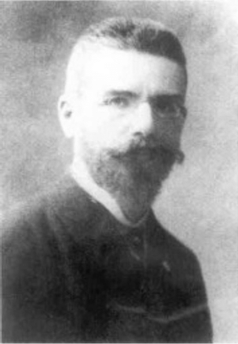 Prof. Otto Lehmann Prof. Friedrich Reinitzer

Detailed Understanding on Liquid Crystals

In general, structural features found in the molecules forming liquid crystal phases are:

1. The molecules are elongated and the existence of strong dipoles with easily polarizable groups.
2. Liquid crystallinity is more likely to occur if the molecules have flat segments like benzene rings.
3. A good rigid core containing double bonds defines the long axis of the molecule.
4. The groups attached to the extremities of the molecules are generally of lesser importance.

Types of Liquid Crystals

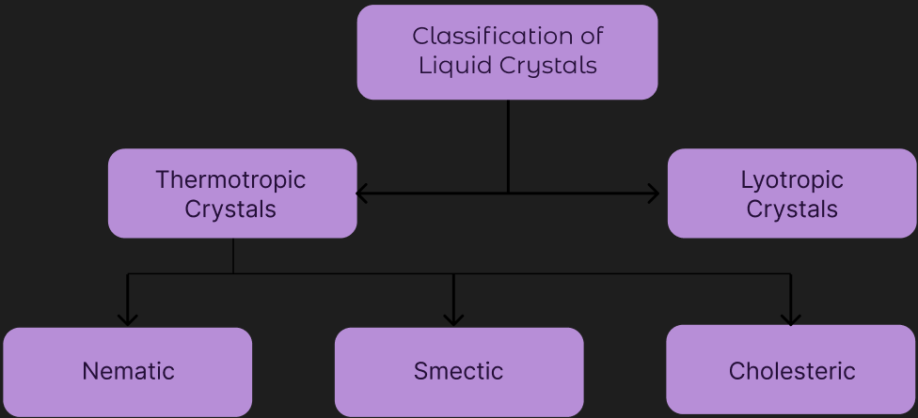

Liquid Crystals can largely be classified into two main categories:

1. Lyotropic Liquid Crystals
2. Thermotropic Liquid Crystals

This classification is on the basis of the mechanism that drives their self organization.

# 1-Thermotropic Liquid Crystals:

Thermotropic transactions occur in most liquid crystals, and they are defined by the fact that the **transitions to the liquid crystalline state are induced thermally**. That is, one can arrive at the liquid crystalline state by raising the temperature of a solid and/or lowering the temperature of a liquid.

They may be rod-like, disk-like or bent. 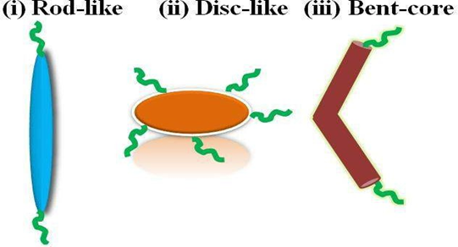

Above is the diagrammatic representation of the same.

They can further be characterized on the basis of certain parameters:

1. Orientational Order: Measure of the tendency of the molecules to align along the director on a long-range basis.
2. Positional order: The extent to which the position of an average molecule or group of molecules shows translational symmetry.
3. Bond orientational order: Describes a line joining the centers of nearest-neighbor molecules without requiring a regular spacing along that line. Thus, a relatively long range order with respect to the line of centers but only short range positional order along that line.

Based on these parameters we can classify the liquid crystals into three types:

1. **Nematic phase**
2. **Cholesteric Phase**
3. **Smectic Phase**

## 1.1-The Nematic Phase

The nematic phase is the simplest liquid crystalline phase exhibited by long rod-like molecules. The word nematic stems from the Greek word "nema" which means thread referring to the thread-like structures seen in this phase. This phase possesses orientational order of the long axes of the molecules about a particular direction referred to as the director $\hat{n}$.

Nematic phase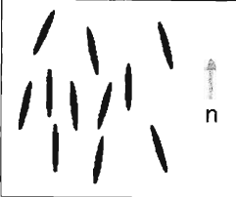

Because of high mobility, **nematic phases show a low viscosity**, very similar to isotropic liquids, with the difference that the parallelism of the long axes induces the anisotropy of many physical properties. Hence, the **Nematic Liquid Crystals are anisotropic in respect to optical properties (double refraction), viscosity, magnetic and electric susceptibility, and electric and thermal conductivities**.

### 1.1.1-Types Of Nematic Liquid Crystals

Subsequent discovery of a new type of nematic phase led to its classification into two subclasses:

1. Uniaxial Nematic: They have **long-distance order in one preferred direction**, when the director 'n̂' does not distinguish between head and tails, that means they can be either pointing in one direction or the opposite direction.
2. Biaxial Nematic: Unlike uniaxial nematics with a single director, **biaxial nematics have two directors**, often denoted as n̂ and m̂. These directors define the preferred orientations of the elongated molecules. The presence of two directors breaks the rotational symmetry, meaning the **material's properties are not the same in all directions**. This leads to anisotropic behavior, where light, electrical conductivity, and other properties vary depending on the direction.

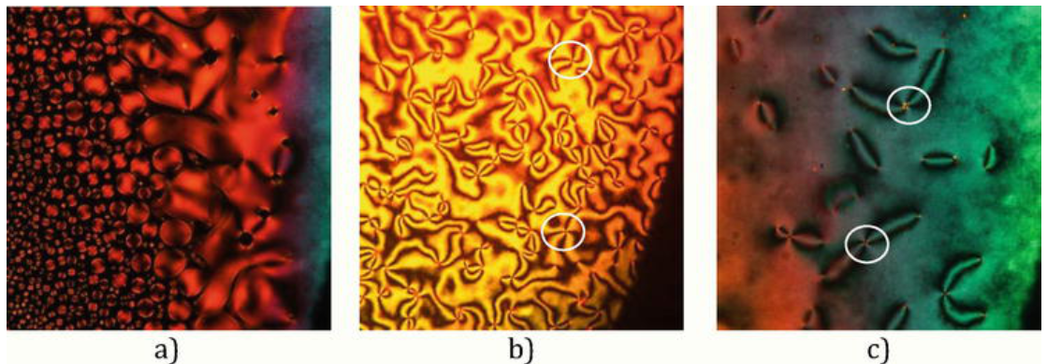

(a) Nematic droplets, (b) Schlieren texture of a presumably uniaxial nematic (four-brush disclinations), and (c) Schlieren texture of a presumably biaxial nematic phase (two-brush disclinations).

### 1.1.2-Molecular Shape of Nematic phase

Materials that exhibit liquid crystalline phases are called mesogens. The relationship between the microscopic shape of mesogens that form the nematic phase and the macroscopic symmetry of the phase affect their physical properties.

The uniaxial nematic phase is found in simplest low molar mass liquid crystals or mesophases represented by compounds made up of long cylindrical-shaped molecules (calamitic mesogens) ([Figure 1a](https://www.intechopen.com/chapters/72382#F1)) or discs (discotic mesogens) ([Figure 1b](https://www.intechopen.com/chapters/72382#F1)); the biaxial nematic phase is found to be prevalent in bent-core compounds (banana mesogens) ([Figure 1c](https://www.intechopen.com/chapters/72382#F1)).

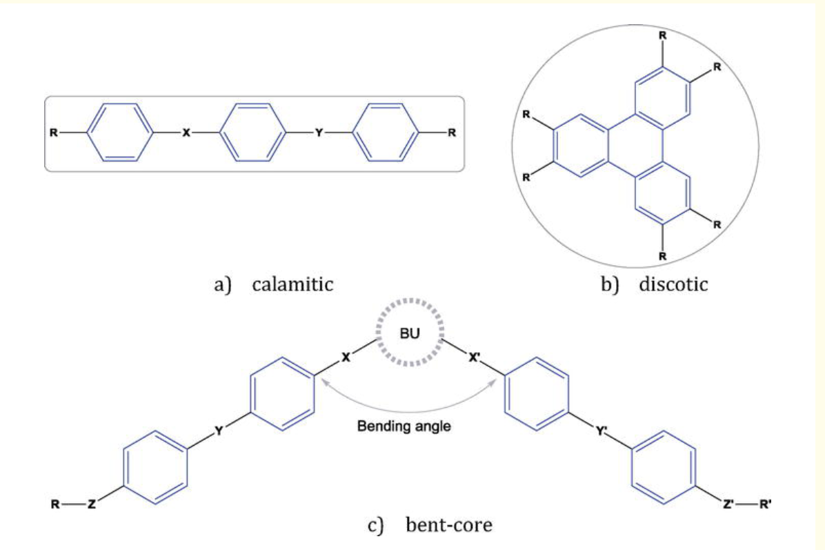

### 1.1.3-Applications of Nematic Liquid Crystals

Nematic Liquid Crystals are the most widely used Liquid Crystals. Some key areas where they are used are:

1. Liquid Crystal Displays (LCD's): This is probably the most prominent way Nematic Liquid Crystals are used. Their ability to manipulate light polarization allows them to control the pixel brightness and color in LCD screens.

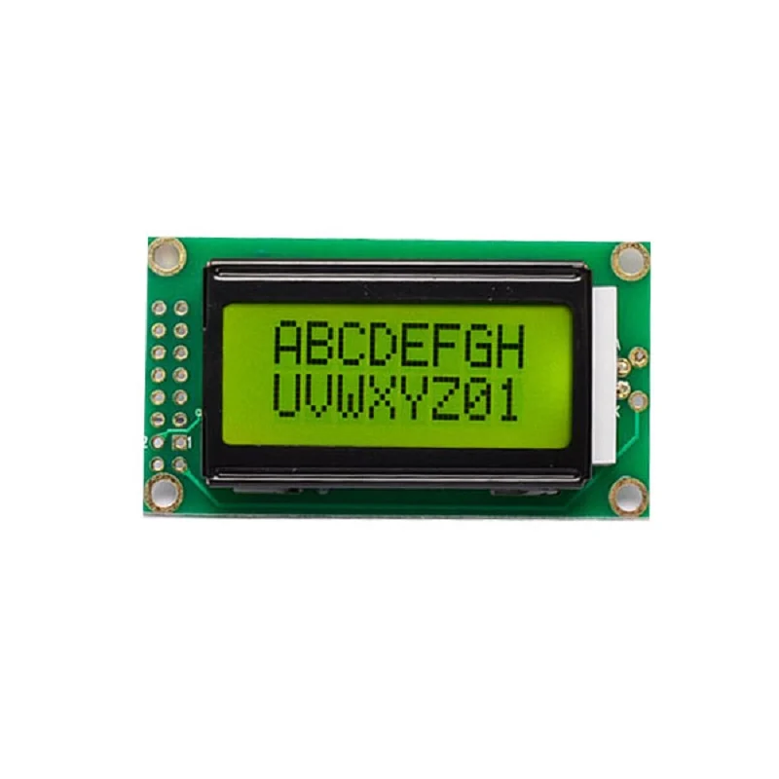

1. Optical Instruments: Beyond displays, Nematic Liquid Crystals are used in various optical devices such as tunable lenses, filters and waveguides.They are used in glasses that adapt to different lighting conditions or lenses that can zoom without moving parts.
2. Sensors: Nematic Liquid Crystals are inherently sensitive to temperature, pressure, and electric fields. This makes them excellent candidates for sensor applications.
3. Medical Imaging: Nematic Liquid Crystals-based optical coherence tomography (OCT) is a powerful technique used for non-invasive imaging of tissues. Nematic Liquid Crystals help focus and manipulate light for high-resolution imaging of the eye, skin, and other organs.

Figure shows Optical Coherence Tomography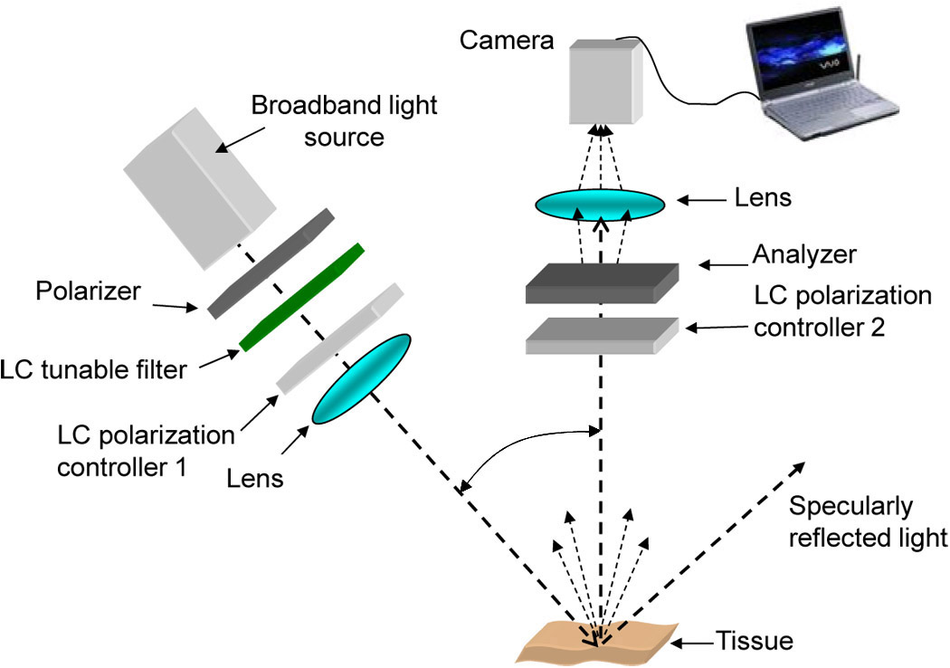

## 1.2-The Cholesteric Phase

Cholesteric liquid crystals or chiral Nematic Liquid Crystals are formed by **optically active molecules**. In this phase the director is no longer constant, but forms a **helical structure causing the chirality of the phase**. Due to the a-polar nature of $\hat{n}$, the periodicity of the medium along the helical axis is half the pitch of the helix. (Chirality: A property in which the mirror image of the molecule cannot be superimposed on it.)

Diagrammatic representation of Cholesteric phase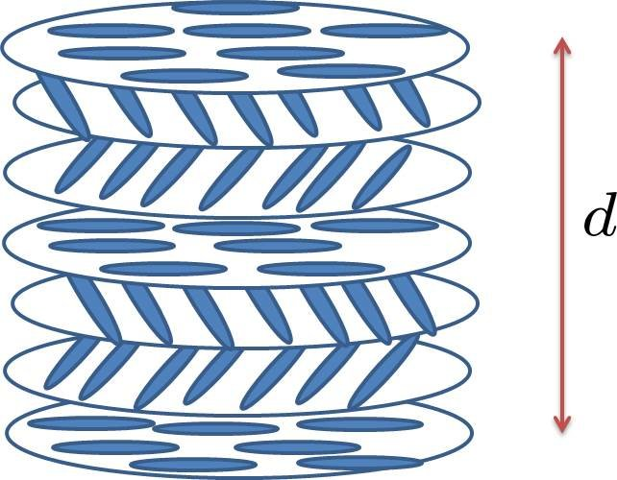

### 1.2.1-Properties of the Cholesteric Phase

The cholesteric phase is like the nematic phase in having **long-range orientational order** and no long-range order in the positions of the centers of mass of molecules. The way it **differs from the nematic phase is that the director varies in direction throughout the medium in a regular way**. The structure of cholesterics is frequently referred to as a **helix** (with the appropriate pitch and axis).

The total distance within which the director rotates from $\hat{n}$ back to $\hat{n}$ is called the pitch and is represented by 'P'. The **periodicity length of the cholesteric is actually only half this distance (pitch) since $\hat{n}$**  **and** - $\hat{n}$ **are indistinguishable**.

The cholesteric phase. The molecules tend to have the same alignment which varies regularly through the medium with a periodicity distance p/2.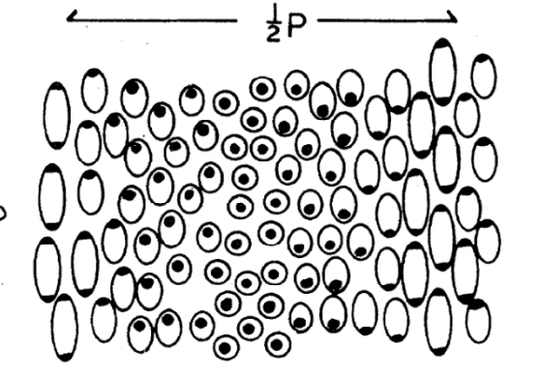

Cholesteric liquid crystals **exhibit a unique reflection of light** due to their helical structure. The **wavelength of the reflected light is determined by the pitch of the helix** and can be controlled by adjusting the molecular parameters of the liquid crystal material.

They are temperature sensitive too. **Changes in temperature can alter the pitch of the helix, leading to shifts in the reflected color.** This property is exploited in thermochromic materials and temperature sensors.

Electric field or mechanical stress, can influence the molecular orientation and alter the helical structure of the cholesteric liquid crystals.

### 1.2.2-Applications of Cholesteric Phase

1. Displays: Cholesteric liquid crystals are used in reflective displays, such as e-paper displays. The reflective nature eliminates the need for a backlight, making them energy-efficient.
2. Sensors: They are employed in temperature sensors, where the color change corresponds to temperature variations.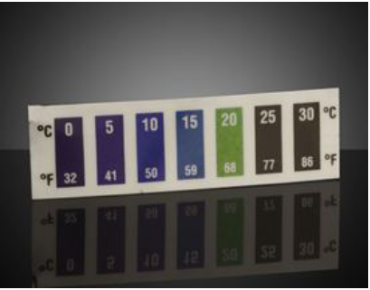

## 1.3-The Smectic Phase

The word smectic means 'soap-like' in Greek. Smectic liquid crystals exhibit long range orientational order like in nematics and in addition, layering perpendicular to some direction.

The following diagram shows the actual difference between Nematic and Smectic A phases.

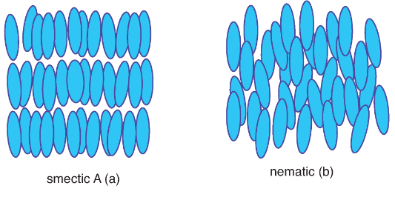

There are three types of smectic phases, namely, Smectic A, Smectic C and Smectic C*.

### 1.3.1-Types of Smectic Liquid Crystals

1. Smectic A: Molecules stacked vertically with their long axes perpendicular to the layer plane.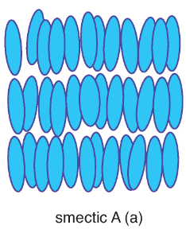
2. Smectic C: Molecules tilted within the layer plane, creating an angle relative to the layer normal.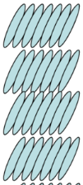

Smectic C

1. Smectic C*: These are similar to Smectic B, but tilting in opposite directions in adjacent layers, leading to a net dipole moment. 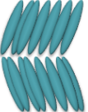

Smectic C*

Following are the three Smectic phases side by side: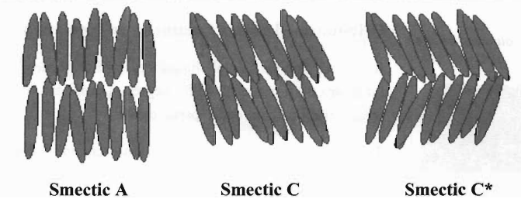

# 2-Lyotropic Liquid Crystals:

Lyotropic liquid crystal **transitions occur with the influence of solvents along with a change in temperature**. Lyotropic mesophases occur as a result of solvent-induced aggregation of the constituent mesogens into micellar structures. **Lyotropic mesogens are typically amphiphilic**, meaning that they are composed of both lyophilic (solventattracting) and lyophobic (solvent-repelling) parts.

Physical Properties ofLiquid Crystals

In this section, various physical properties of liquid crystal phases are discussed. Each mesophases has specific properties. The study of these properties is essential for exploiting the materials for diverse applications. The important physical properties of nematic and smectic mesophases have been discussed here.

# 1-Conductivity

AC conductivity in Liquid Crystals is mainly offered by the ion charges present in the Liquid Crystal material, therefore the measurement of ac conductivity is an important tool to analyze the ionic charge screening in pure Liquid Crystals and Liquid Crystal- nanomaterial composites. If dopant nanomaterials have capability to adsorb the ionic charges (or ionic impurities), on their surface due to high surface to volume ratio, the measurement of ac conductivity is more important. AC conductivity is frequency and temperature dependent physical parameter for Liquid Crystals. The a.c. conductivity (σ ac) can be given by:

σ =2πf εoε = ~~w~~ εoε”

where ω is the angular frequency, ε΄΄ is the dielectric loss and εo is the permittivity of free space.

# 2-Elastic properties

When a distortion is induced in a system, an elastic restoring torque tends to restore the undistorted state. Liquid Crystal molecules always try to tend along director. In Liquid Crystal, three types of deformations exist named as splay, twist, and bend linked with elastic constants K1, K2, and K3, respectively. 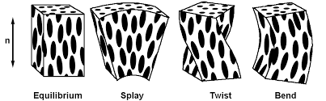

# 3-Orientational and Positional Order

To specify the amount of orientational order in Liquid Crystals phase, the scalar order parameter is used and given by Order parameter S=1 (for a perfectly oriented system) and S=0(for no orientation). Order parameter of Liquid Crystal decreases as temperature increases. S = (0.3 to 0.9) typical values. The value for nematic phase is 0.4 to 0.7, for smectic is 0.8.

Note: 'Director' is the average direction of the long molecular

axes in Liquid Crystal Phase.

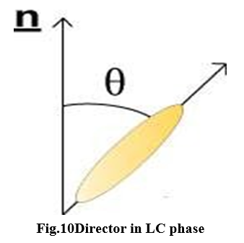

Here n^ is the director. In most of Liquid Crystal both upward and downward director are equivalent. Director gives direction of preferred orientation of Liquid Crystal molecule.

# 4-Dielectric Anisotropy

The property of Liquid Crystals that separates them from liquid is a small degree of order among the Liquid Crystal molecules. This order destroys the isotropy of liquid and produces anisotropy. Uniaxial Liquid Crystals being anisotropic have two dielectric permittivity, one along parallel and other along perpendicular direction about director.

# 5-Optical Anisotropy (Birefringence)

Anisotropy of LCs causes light polarized along the director n to propagate at a different velocity than light polarized perpendicular to it. This phenomenon is called optical anisotropy. 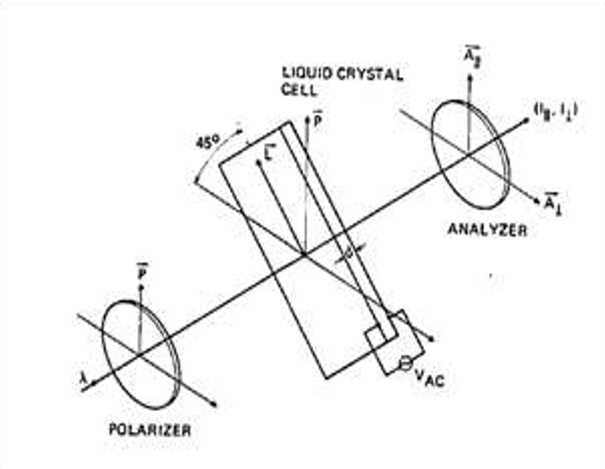

Schematic diagram of the arrangement that can be used to observe birefringence of liquid crystals.

Application of Liquid Crystals

Here we will discuss about the application of LC in different fields and equipment.

# 1.Liquid Crystal Solar Cell

Liquid crystals are organic molecules like polymers, so they have vast applications in the field of LCs semi- conductor. Need for liquid crystal applications is still required and still growing. Liquid crystal in fluid form is used to detect electrically generated hotspots for failure analysis in the semiconductor industry.

# 2-In Medicines

Use of cholesteric liquid crystal as an infection detection and diagnostic tool in medicines has become widespread. Skin defections and some infections may be detected by use of devices made by cholesteric liquid crystals.

# 3-Displays

LCs displays provide a high picture quality.it came very useful as device technology. A liquid crystal display device is formed by attaching a thin transistor array substrate and a color filter substrate face to face with uniform interval between them and placing liquid crystal layers between thin film transistor array substrates.

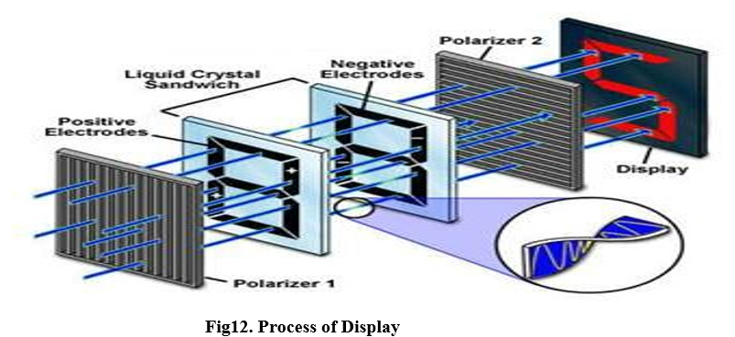

# 4-Optical Imaging

To obtain this, a liquid crystal is placed between two layers of photoconductor. on application of light to the photoconductor, which increases material’s conductivity. This causes an electric field to develop in liquid crystal corresponding to intensity of light. There are many other applications for liquid crystal display such as in vehicle clocks, CRT, speedometers, niche products and spatial light modulators.

# 5-Nanoparticles in LCs

Over the last two decades the development of nanomaterials and nanostructures has had tremendous innovative impacts on science technology. liquid crystal state providing the significant success. Nanoparticles (generally composed of semiconductors, metals, ceramics or oxides) have at least one dimension of the order of 1–100 nm. At the lower end of this length scale, quantum confinement effects dominate leads to tunable electronic, optical, mechanical, and chemical properties. Crystalline nanoparticles referred to as nanocrystals. An interesting interplay exists in the packing arrangement, especially in small nanocrystals.

Nanocrystals usually have a polyhedral surface morphology.

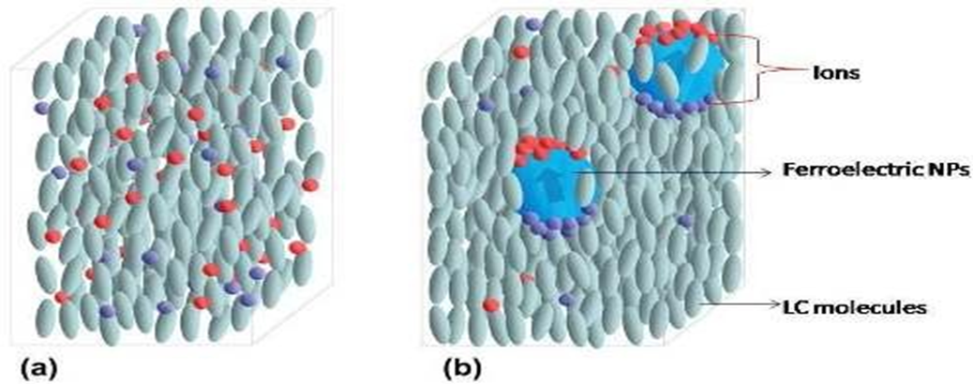

(a) represent random distribution of free ions in nematic phase and figures.

(b) represent nanoparticles ion trapping process in nematic LCs.